**Database -** is a collection of related data

**DBMS -** Database Management System (DBMS) is a software for storing and retrieving users' data while considering appropriate security measures.

**Types of DBMS:**

* Hierarchical database
* Network database
* Relational database
* Object-Oriented database

**RDBMS** - A relational database management system (RDBMS) is a common type of database that stores data in tables.

**Primary Key:** A primary key is used to ensure data in the specific column is unique. It is a column cannot have NULL values.

**Foreign Key:** A foreign key is a column or group of columns in a relational database that provides a link between data in two tables.

**SQL** - Structured Query Language is a standard language for accessing and manipulating databases.

**SQL commands are mainly categorized into four categories**

**DDL** – Data Definition Language

**DQl** – Data Query Language

**DML** – Data Manipulation Language

**DCL** – Data Control Language

**SQL is for relational DB and NoSQL is for non-relational DB**

**DML** – Data Manipulation Language , used for manipulating data in the table.Below are the DML commands,

INSERT

UPDATE

DELETE

**DQL** - Data Query Language, used to fetch the data from the database.Below are the DML commands,

SELECT

**Important Keywords**

**SELECT and FROM:** This is the “heart” of any SQL query - SELECT columns FROM table.

**WHERE:** This acts as a filter and allows you to select only relevant rows based on conditions.

**GROUP BY:** is used to arrange identical data into groups with the help of some functions.

SELECT COUNT(CustomerID), Country  
FROM Customers  
GROUP BY Country;

**ORDER BY**: is used to sort the result-set in ascending**(default)** or descending order.

SELECT * FROM Customers  
ORDER BY Country DESC;

**AVG/SUM/MAX/MIN:** These are aggregate functions that help you summarise the data.

SELECT AVG(column_name)  
FROM table_name  
WHERE condition;

**To find second highest max salary,**

SELECT name, MAX(salary) AS salary

FROM employee

WHERE salary < (SELECT MAX(salary)

FROM employee);

**COUNT :** Count helps you find the number of entries

SELECT COUNT(column_name)  
FROM table_name  
WHERE condition;

**DISTINCT:** Distinct helps you find unique entries.

**UNION:** The UNION operator is used to combine the result-set of two or more SELECT statements. UNION ALL allows duplicate values.

SELECT column_name(s) FROM table1  
UNION  
SELECT column_name(s) FROM table2;

**Join** - Join statement is used to combine data or rows from two or more tables based on a common column between them.

**Inner Join -** Returns records that have matching values in both tables.

SELECT table1.column1,table1.column2,table2.column1,.... FROM table1 INNER JOIN table2 ON table1.matching_column = table2.matching_column;

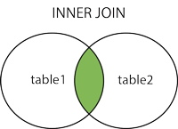

**Left outer join -** Returns all records from the left table, and the matched records from the right table

SELECT column_name(s)  
FROM table1  
LEFT JOIN table2  
ON table1.column_name = table2.column_name;

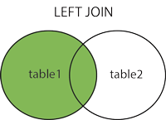

**Right outer join -** Returns all records from the right table, and the matched records from the left table

SELECT column_name(s)  
FROM table1  
RIGHT JOIN table2  
ON table1.column_name = table2.column_name;

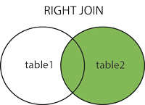

**Full outer join -** returns all records when there is a match in left (table1) or right (table2) table records. It simply combines the result of left and right join.

SELECT column_name(s)  
FROM table1  
FULL OUTER JOIN table2  
ON table1.column_name = table2.column_name  
WHERE condition;

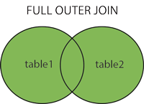

A **connection string** provides the information that a provider needs, to communicate with a particular database. The Connection String includes parameters such as the name of the driver, Server name and Database name , as well as security information such as user name and password.